

Universidad Tecnologica de Tijuana

Desarrollo de Software Multiplataforma

Subject:

Desarrollo móvil multiplataforma

Teacher:

Ray Brunett Parra Galaviz

Students:

Alvarez Galindo Aldo Yamil

Gómez Miramontes Daniel

Mayo Ramos Ángel David

Muñoz Reynoso Oscar Gael

Introduction:

The Workbit system will be deployed in designated study rooms, reading areas, and small classrooms. Its functionality supports environmental monitoring, attendance tracking, room readiness automation, and analytics dashboards for resource optimization.

Description of the problem.

Environments with Poor Air Quality

Many classrooms and workspaces lack adequate ventilation.

High CO₂ levels affect concentration, performance, and health.

There are no alerts or indicators visible to users or administrators.

Lack of Automation in Space Management

The use of cubicles or rooms is managed manually, without precise control.

There is no automated record of who enters or how long they stay.

General objetive

Develop an intelligent workspace management system that, using IoT technologies and role-based digital access, automates environmental control, records space usage, and facilitates real-time monitoring from web and mobile platforms.

Progress in front-end mobile app

1. section to view the spaces

In this section we can visualize the spaces that are available, those in green are those that are available for reservation, those in red are those that are currently being occupied and finally, those in orange are those that are already reserved.

1. booking history

On the history side we can visualize all the reservations we have made and filter them by the reservations that have already been completed, by those that are pending or scheduled and by those that are active.

1. environmental monitoring

Once the user has entered his space, he can visualize its conditions, such as CO2, temperature, humidity and even noise.

Progress in back-end mobile app

1. code for reservations

The following code shows the reservation system controller, which receives the data needed to make a reservation and executes an insert procedure in the database.

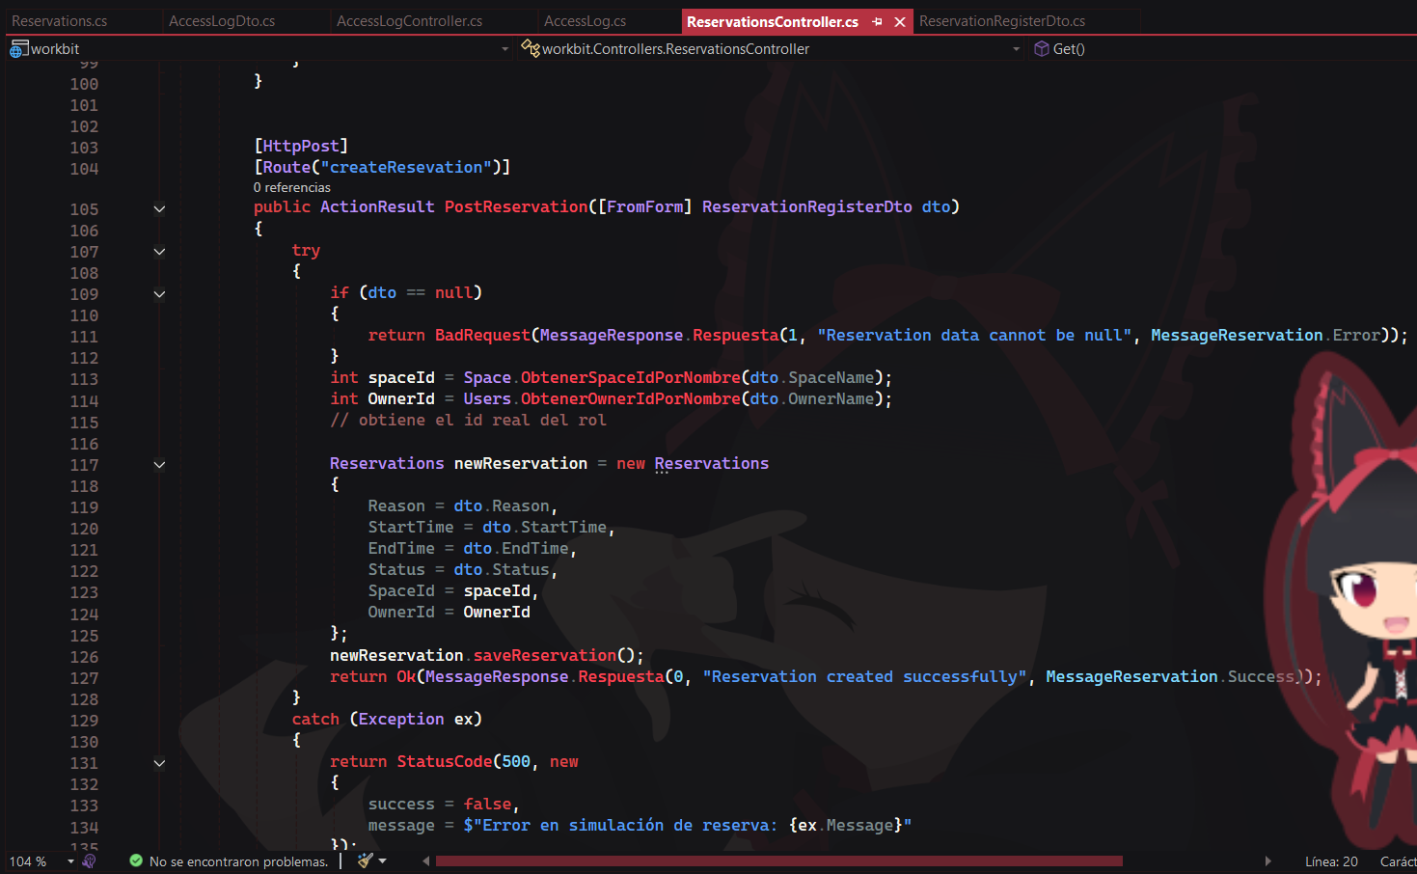

1. code for access control

The following code shows the functions to insert a new record into the database, which is a new access to a workspace.

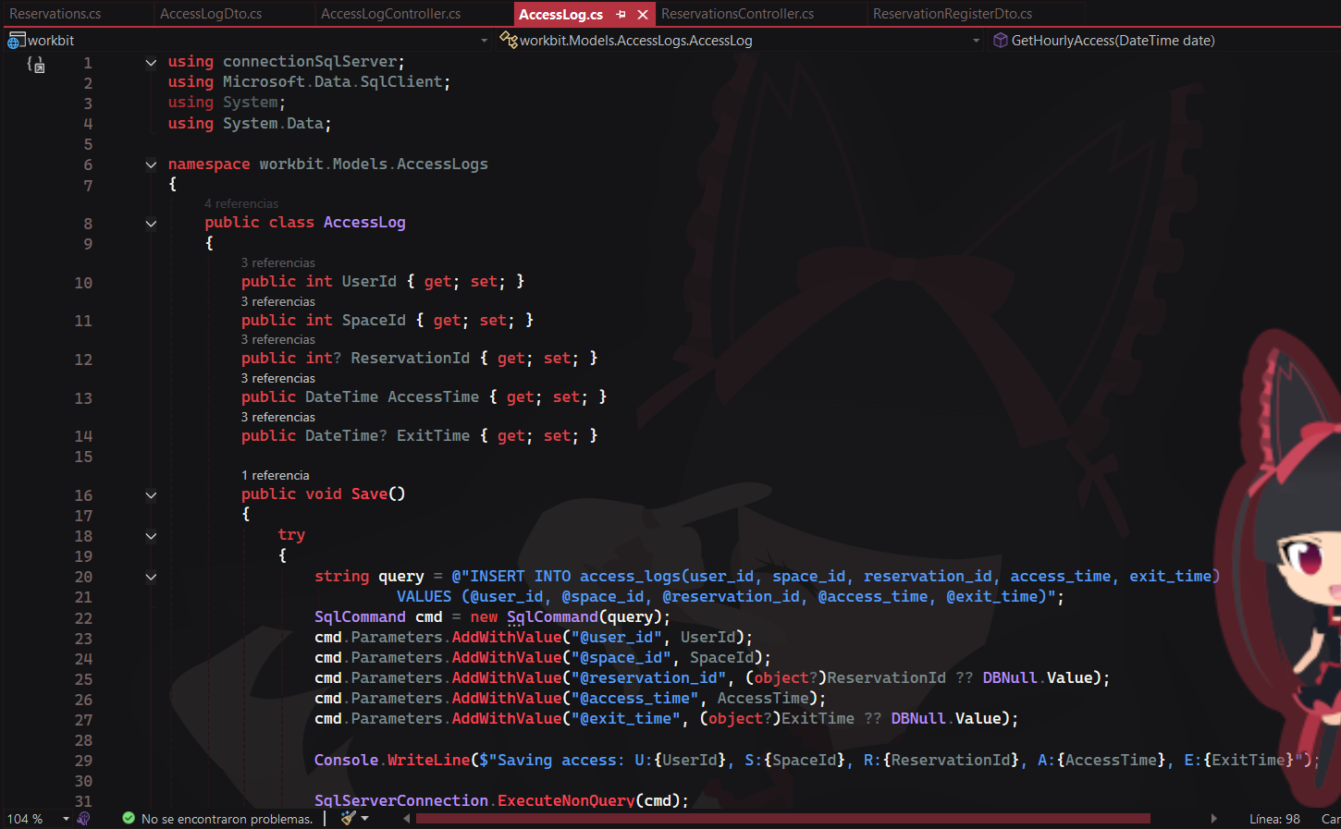

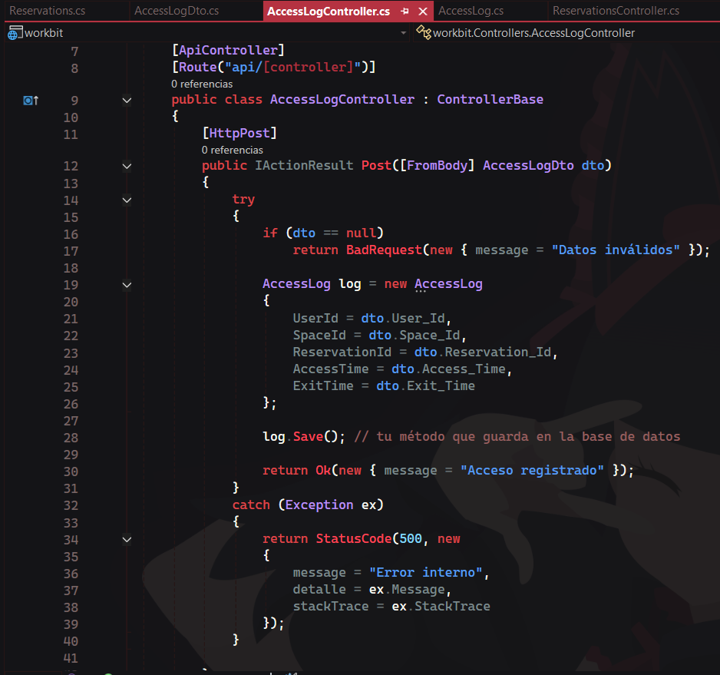

1. login code

In the following code, you manage which dashboard each user is sent to according to their role.

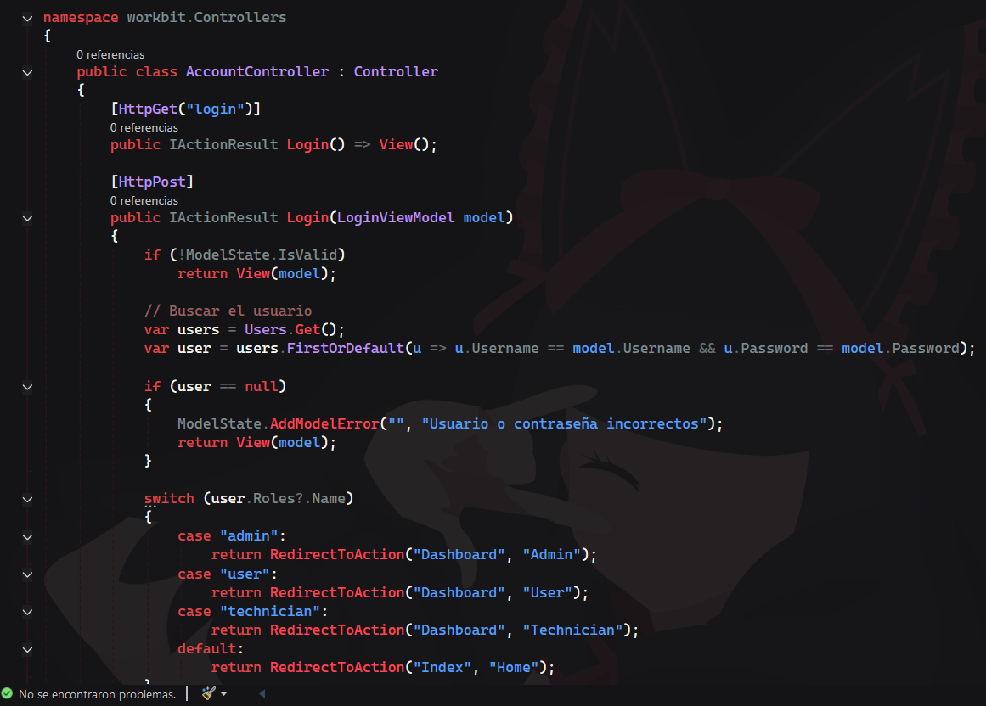

1. code for role control

The following code is for each user's dashboard according to their role.

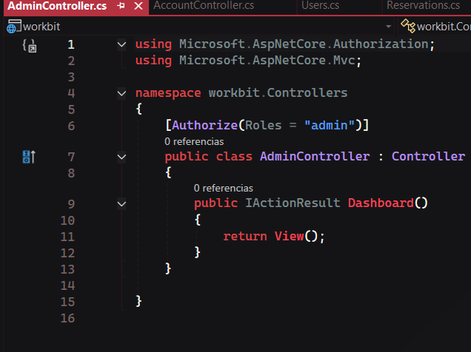

1. code for user functionalities

In the following code, perform simple actions with the user's data, such as registering them or displaying their data to update them.

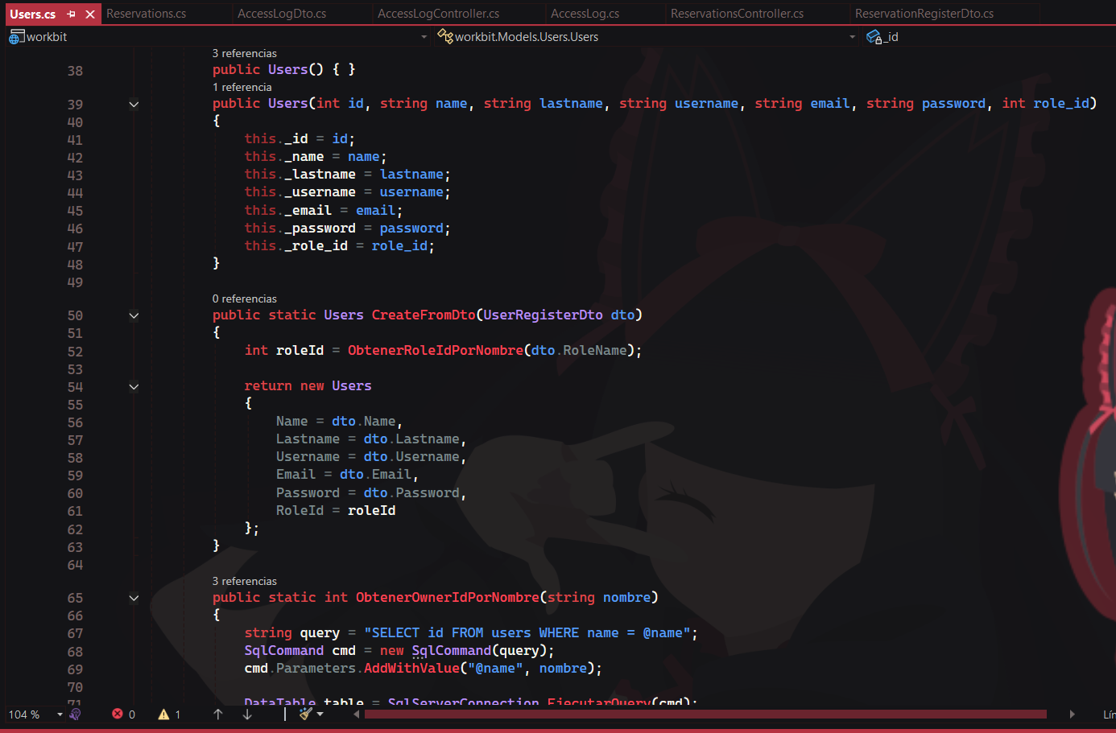

Coclusion

This first preview shows the development of the main functions of the mobile app already working and operating without any errors. At this point, all that remains is to finish the minor functionalities and complete the front-end development.